Central Connecticut Woodturners
Dedicated to the Advancement of Woodturning
www.ccwoodturners.org

A Chapter of the American Association of Woodturning
April 2006 Issue
CCWoodturner’s President’s Note:
Next Meeting:
March 28
at CVSW
April 25 meeting at Bolton Woodturning/ Turning 70 (in roman-tic Willimantic) Mike South demonstrating his spiral machine.

Business Meeting 7:00pm
Program/Demo.
7:30pm

Upcoming Events:
May 23 meeting at CVSW. Angelo Iafrate’s latest slide show and Demo of turning a magic trick. June 27 - TBD

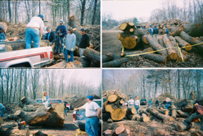
Many thanks to Chris and Lynda Zibbideo, Howard Loos, Steve Bemont, Marie and Don Tyrseck, Alan Moltz, Mark Lefebvre, Bob Ginter and Laura Anderson, for going to the Cromwell Transfer Station on April 1st to collect pieces of wood. A very nice piece was found in the pile for the bench. The bench will be displayed in the Town Hall in memory of the First Selectman who years ago planted the tree. Howard Loos took the piece of the tree to the sawmill at Steven Strong’s house in East Hampton and had it cut into slabs. Legs will need to be turned and then finishing the bench. Thank you Howard and Steve. All the vehicles we had on Saturday were filled to capacity with wood.
On Saturday, May 6th, at 9:00am CCW members will have another opportunity to collect more wood. There is still plenty of wood to be collected. We can go back to the Transfer Station and finish collecting the Cromwell Oak.
The Transfer Station is on Route 3, Shunpike Road and is marked by signs. Hope to see you there.
- Corey Anderson

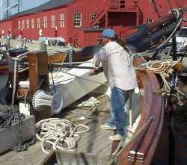
CCWoodturners and
The Freedom Schooner Amistad
In 1839 fifty-three Africans from the area now known as Sierra Leone were captured into the North American slave trade and forced onto a Spanish vessel called La Amistad. One of them, a man named Singbe Pieh, escaped from his chains and led a shipboard revolt.
The victorious Africans ordered the two surviving crew members to sail them toward the rising sun, back to Africa. Instead, they were tricked as the ship was turned back toward the coast at night. The Amistad zigzagged up the
Amistad (Continued from Page 1)
eastern U.S. coast and ended up in the harbor at New London, Connecticut. When Spain demanded the return of "Spanish property", there ensued one of the most important civil rights cases in U.S. Supreme Court history. Ultimately,
under a legal defense headed by the former president John Quincy Adams, the Court upheld the freedom the Africans and, more importantly, their right to self-determination. The decision and its surrounding publicity fuelled the growing abolitionist movement in this country. In January of 1842 the thirty-five Amistad Africans who had survived the ordeal were returned to their homelands.
In 1999 Mystic Seaport's shipyard staff began construction on a working replica of the sailing vessel, Amistad, as a permanent symbol of the struggle for equality and human rights. The ship is a floating educational resource to ensure this very important part of American history is never lost.
During the construction, Mystic Seaport staff asked CCW to turn the belaying pins, parrel beads and damage control plugs for the reconstruction. Since the launch in 2000, our members have created hundreds turned items from the cut-offs and scraps left over from the construction of the vessel. Funds raised from the sale of these items are used to develop shipboard educational curricula and to promote the mission of the Amistad. There is always something to do on a wooden sailing vessel. In the spring of the past two years CCW volunteers have performed much
– John Lorch

Page:
2 of 6
Central Connecticut Woodturners
Meeting minutes for March 28, 2006

The March meeting of the Central Connecticut Woodturners was held at Connecticut Valley School of Woodworking located at the Manchester Woodcraft. President Corey Anderson called the meeting to order at 7:00PM.

President Report: Cory Anderson
- Corey welcomed guests and new members.
- Corey thanked all that participated in the S. Windsor Public Library display. Friday March 31st all displayed items must be picked up. Some discussion was brought up regarding individuals wanting to sell their displayed items. It was advised that the turner would conduct the sale outside of the library.
- THE Cromwell Oak has been moved to the Cromwell Transfer station. Looking for a chain saw party to meet Saturday April 1st at 9AM to cut apart the tree. CCW will be donating a bench back to the Town of Cromwell. All those that come to the chain saw party and take a piece of wood are requested to turn a piece that will be donated back to the town.
- One year later another tree will need removal. The Cromwell Hangin’ Tree. Yes, they did hang people from this tree! Corey is in contact with someone that is interested in doing a documentary on the entire process. From the tree felling to chain sawing to turning to the final donation of the piece.
- Discussions were brought up regarding what to do with the Delta lathe that CCW won. Options include sell it (school/eBay/member), raffle it off, auction it off at the summer picnic or keep it. Presently the lathe is stored at Gil’s shop. It was decided to table this until the next meeting so that all have time to mull over the options.
- Utah Symposium.
- Allan Lacer will be at the CNEW on May 11th. Admission is $15.
- Louisville, KY Symposium.
- Assorted magazines and applications to AAW were on the front desk for all to take.

Vice President Report: Albert D’Antonio
- Sunday 4/23/06 there will be a show in Rockville, CT sponsored by the TKB Club. This show will be showcasing Rockville and Vernon artists.
- June meeting/picnic – although we got Mary’s OK, we were unable to book Cindy Drozda for the picnic. On June 17th Jean-Francois Escoulen (www.escoulen.com ) will be at the Wickford Library in Rhode Island, admission $10 includes lunch. More information to come. Other suggestions are welcome.
- July 25th at CVSW- “Flea Market/Tag Sale/Swap Meet”. Time to clean out the shop of items that you tried & don’t work for you, don’t fit your machine, the “just had to have” items, wood, tools, etc.
- September 26th at CVSW Mike Allison & wood piercing & colors
- October 24th Bolton Woodturning/Turning 70 in Willimantic. Turning toys frenzy. Tops, kaleidoscopes, wooden soldiers, dolls, cars, etc. Donations will go to the Marines Toys for Tots collection.
- November 28th at CVSW. From the Amistad’s Iroko that was given out at the March meeting all pieces are to be returned for the Club challenge. As stated in the January meeting: The turner will be getting 2 pieces of wood. 1 piece is for the club challenge in November and the other is to make a turning that will be donated back to the Amistad. Also that night will be a picture board of various club members’ shops. See how different people layout their shops for convenience, ease of use, manageability or how make the most out of a small space. Start taking Meeting Minutes (Continued from Page 3)
- pictures of your shop!
- December 9th The club Holiday Party.

Treasurer’s Report: Alan Moltz
- CCW is 74 members strong!
- For February
Beginning Balance $3,249.45
Income: 630.00 (Dues)
Expenses 334.38 (DVD for club library, Beth Ireland presentation, misc. checks)
Ending balance $3545.07

Secretary’s Report: Lynda Zibbideo
- Nothing to report.

Newsletter: David Miner
- DavidMiner1228@sbcglobal.net
- If on the mailing label of your newsletter there is a “last Issue” on it. Your dues are way over due and you will be dropped from receiving any new newsletters until you are paid up.
- Dave read to all a thank you letter from a professor that took his first wood turning class with Ken Dubay. Ken was very understanding & took the time to explain things thoroughly. The professor said that Ken was a great teacher & recommended that it was a class worth taking.
- Looking for any news worthy items for the newsletter: book reviews, new products, web sites, pictures of your turnings, stories, etc. If you send in items to the above email address, please use Comic San 10pt. Items can also be mailed in.
- Submission deadline is 10 days after the meeting. This will allow David to organize/format the newsletter & get it out on time.
- Put out to the club whether it is preferred to have the newsletter mailed, sent via email or just out on our website www.ccwoodturners.org. Half of the members have signed up for email newsletter. This is a great saving to the club!!!

Miscellaneous Business:
- John Lorch: the first work party was on Saturday 3/18 at 9AM and all went well. Please note that there is still stuff that needs to be done. So come on down. If you come on down & work on the Amistad -they do give the volunteers a thank you cruise. John brought in some Iroko wood for the wood swap with a catch. On June 26th at Foxwoods there will be an auction, the CCW Iroko turned pieces are to be part of the auction. If you took a piece(s) of the Iroko tonight, your turned donated pieces have to be returned at the May meeting. You can turn anything…pens…bowls…plates…cups...goblets.
- Gil Hite advised us that CCW’s new delta lathe is at his shop. He has composed a thank you letter and a poem that he wants to send on behalf of CCW to Delta thanking them for the donation of the lathes. Gill also requested that everyone please wear your nametags & put them back in the numbered slot at the end of the night. Pictures were taken of the Chaplin pieces and will be displayed at the Senior Center. Never too early to start thinking of the WAAC show (Thanksgiving to Christmas show). Gil has started to receive wood from various Windham trees (box elder so far)
- Al Czellecz has a pattern makers’ lathe for sale if anyone is interested please contact Al for more details. Al suggested that perhaps the club could invest in new video equipment with a projection screen. With the great demonstrations that we have lined up, sometimes it is hard to see what is happening at the lathe from the back row.
- Wood swap and Show & Yell
  - Rick Angus – 3 lidded boxes (red oak, white oak & apple)
  - Ken Cuarner – 2 Iroko boxes done in the style of Beth Ireland’s “thinking outside the Box” Donated to the Amistad
  - James D’Angelo – Iroko low hollow bowl
  - Ken Dubay – tall vase of box elder
  - Brad Hoyt – spalted maple slice (aka trivet)
  - Howard Loos – 4 small bowls & a vase made of Iroko made for the Amistad donation. 2 natural edge sumac bowls (nice lime green color)
  - Rick Meier – box elder “20th Anniversary Bowl”. Ash platter
  - Al Moltz – 2 segmented bowls using 4 different color woods
- Presentation followed given by Mike Allison. Mike demonstrated various hollowing techniques. For your first hollowing project Mike suggested not try to hollow out a bowl with a tiny 2inch opening…..start bigger. And start simple. There are many types of hollowing tools on the market. Mike showed how orienting the wood on the lathe would give your bowl different features, looks & challenges. Mike brought many of his pieces to show these concepts. Mike then attached his laser guided hollowing tools and let the wood chips fly.
- Next meeting: April 25th 7PM at the woodshops of Bolton Woodturning and Turning 70. Featuring Angelo Infrate www.tamarindwoodturning.com
Respectfully submitted,
Lynda Zibbideo

Continued on Page 3

3 of 6
Page:

Continued on Page 4

Page:
4 of 6

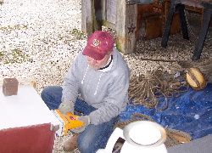
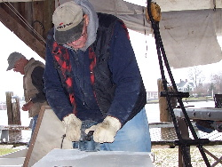
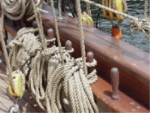

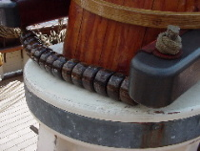

~ Legal Stuff ~
The Central Connecticut Woodturners (CCW) was founded in 1994 to support the needs of woodturners in the central Connecticut area. Its purpose is to promote a higher standard of excellence in woodturning by providing an ever expanding source of information and resources to its membership. Memberships are calendar basis from January1 through December 31. Annual dues are $35 or $20 for six months or less.

President: Corey Anderson
(860) 267-0830
wooden-it-be-nice@sbcglobal.net
Vice President: Albert D'Antonio
(860) 295-1347
Treasurer: Alan Moltz
(860) 665-0284
alanmoltz@cox.net
Secretary: Linda Zibbideo
(860) 686-1207
czippy@msn.com
Librarian: Dayton Stimson
(860) 644-6160
dstimson@thirousa.com
Newsletter Editor: David Miner
(860) 447-0161
davidminer1228@sbcglobal.com
Webmaster: Mark Lefebvre
(860) 559-4095
mark.lefebvre@comcast.net

Video Coordinator - Tom Stevenson
(860) 643-9214
milton_stevenson@UHC.com
5 of 6
Page:

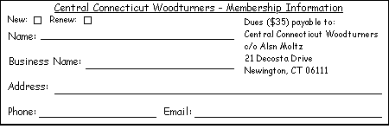
Alan Moltz
CCW Equipment
The CCW owns a 10x10 easy-up tent including 4 sides; 2 CCW banner; and a lighting system recently donated by Jim equipment is stored at Gil Hite's shop. Call 860-933-4038 to reserve for your show(s).
Classified Ads
Sears/Craftsman Air Compressor, 3 Gallon, 125PSI, Oil Lube 1HP Used less than 20 hours $ 75.00 firm
Call Corey Anderson – 860-267-0830

Woodturning Lathe, Heavy-duty, 1890 vintage, Cast Iron, 6ft long, 48” between centers, 6 ½” swing $200. Must sell – Moving
Call Roland Benoit 860-774-0525

Master woodturner, Ken Dubay, offers one-on-one lessons. One, two, or three day courses are available. Ken specializes in natural edge turnings. Lunch and all materials are included. Call: (860)228-2695

FYI: CCWoodturners’ embroidered shirts and hats are available from “The Finest and the Bravest” (www.thefinestandbravest.com)

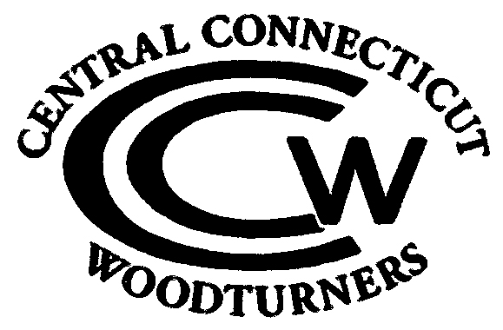
Central Connecticut Woodturners
C/o David Miner
842 Chesterfield Road
Oakdale, Ct 06370

